Created by: David Rubio G.
Blog: https://soceame.wordpress.com/
GitHub: https://github.com/DRubioG
Last modification date: 11/03/25

In this post I will explain how to instantiate an IP block in FW in Libero. To do this, a real example will be used, for which a PLL is to be placed in a block of LEDs created by the user.

Development
The first thing you need is the FW module in which you are going to instantiate the IP block.
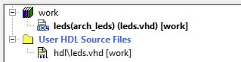
Now you go to the Catalog, here you choose the IP block you want to instantiate. In my case I am going to instantiate a PLL.
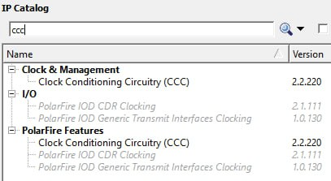
When you click on it, the PLL configuration tab opens. Here we configure the PLL as we want.
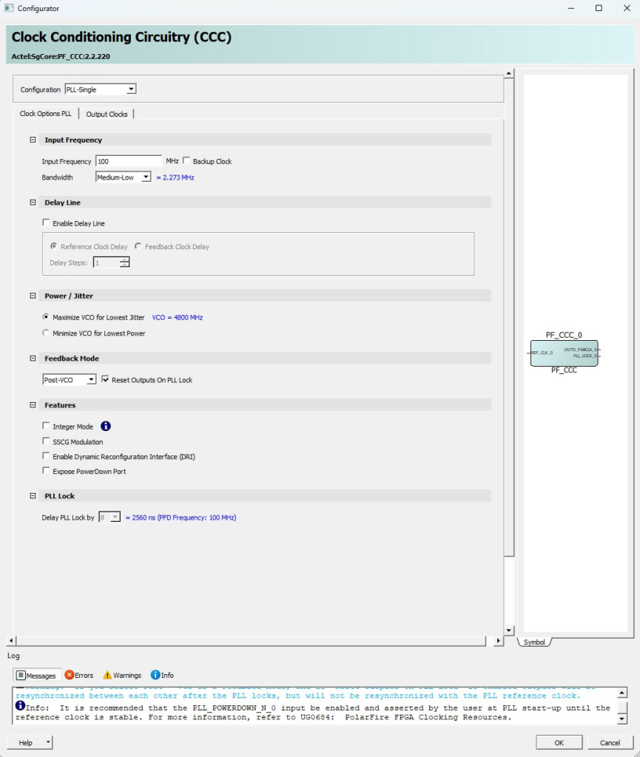
We configure it with the desired output frequency.
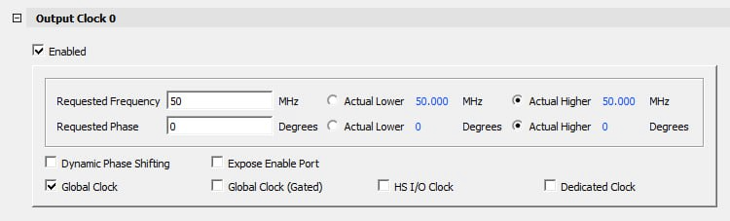
When you finish the configuration, the IP block appears in the hierarchy at the same level as the FW.
NOTE: this would be where you normally drag the IP block to a SmartDesign and join it.
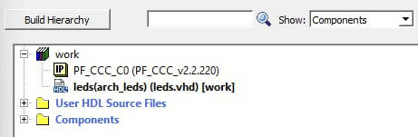
Now what you have to do is change the view from the Components hierarchy to the Modules view.
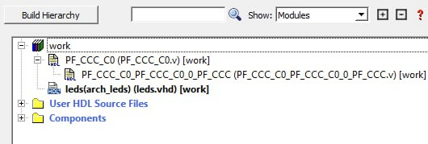
Now you can see two modules to implement the PLL, both in Verilog. We are only interested in the top module of the PLL, the PF_CCC_C0.
If we open it we can see that the port system is the same as the PLL we have configured.
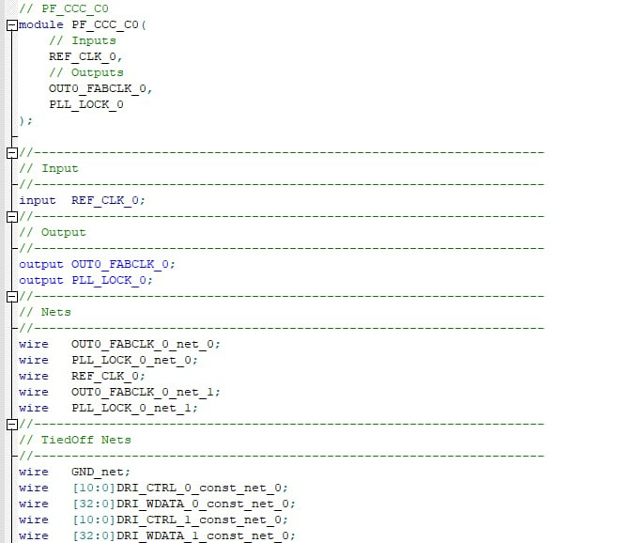
Now all we need to do is take the ports from the Verilog file.
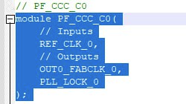
Now we paste these ports into our project. And if we are working in VHDL we convert it into a component with the information given to us by the file.
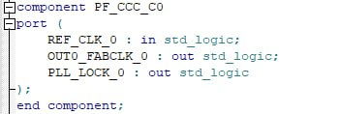
Now we only have to instantiate the IP block with our FW.
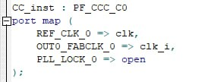
By doing so the hierarchy shows us that the PLL is downstream of the FW module.
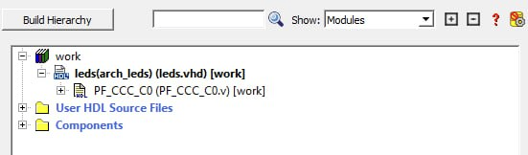
If we change the view from Modules to Components the structure is better reflected.
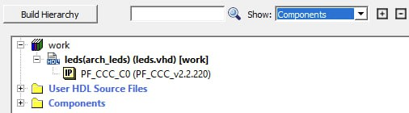
If we now synthesize the FW, we can see that Libero does not give any kind of error, and that it synthesizes the entire FW, including the PLL.
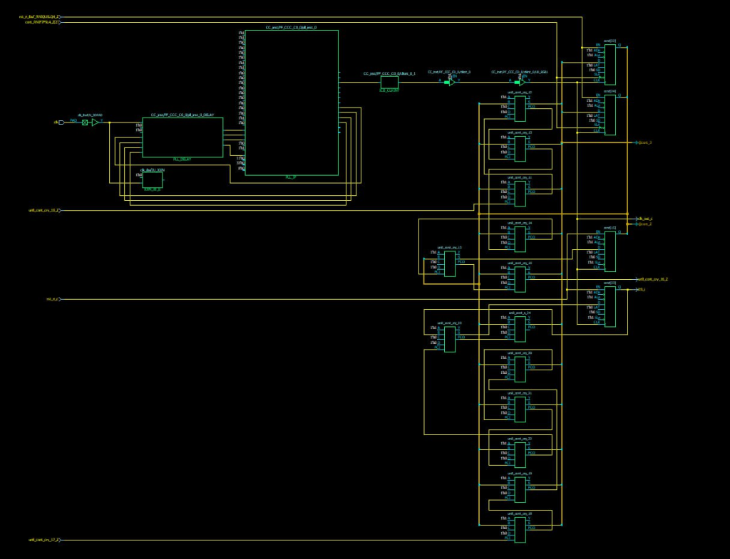
And if we look closely at the synthesis we can see that there is a part that corresponds directly to the PLL we have instantiated.
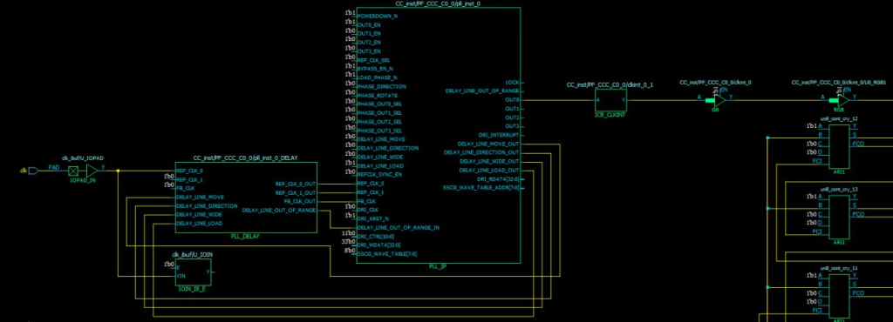

FINAL NOTE
Well, the same thing that has been explained with a PLL can be done with all the Libero IP blocks. And thus, you don’t have to use SmartDesign.

